Academic Year: 2025-26 | Year: Second Year | Semester: II
PRN No.: 1012411011 | Name: Riddhee Kulkarni
Subject: Python Programming
Assignment No.: 10
Date: 05/01/2026

Lab Assignment: 10
Aim:
To write a Python program to calculate the sum and average of the first 10 natural numbers.

Objective:
To use a for loop to find the sum and average of natural numbers from 1 to 10.

Theory:
Natural numbers are positive integers starting from 1.
A for loop is used in Python to repeat a block of code for a fixed number of times.
The sum is calculated by adding each number in the loop, and the average is obtained by dividing the sum by the total count.

Algorithm:
- Start
- Initialize sum to 0
- Use a loop from 1 to 10
- Add each number to sum
- Calculate average as sum ÷ 10
- Display sum and average
- Stop

Pseudo Code:
START
sum = 0
FOR i = 1 TO 10
sum = sum + i
END FOR
average = sum / 10
PRINT sum, average
STOP

Code:
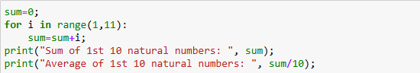

Output:

Conclusion:
The program correctly calculates the sum and average of the first 10 natural numbers using a for loop.

